Assignment 1

Student Name: Durvank Deorukhkar
Course: Survey of System & Programming language

How the Student Grading System Works
The Student Class
I designed the Student class to store all the information about a student and handle grade calculations. It keeps track of:
- Basic info (FirstName, LastName, ID)
- Two test scores (Test1, Test2)
- A ComputeGrade() method that calculates weighted averages and determines letter grades
Here's how I structured the properties using full get/set accessors:

private string firstName;
public string FirstName
{
get { return firstName; }
set { firstName = value; }
}

The Grading Logic
Instead of just averaging the two test scores, I implemented a weighted system:
- Test 1 counts for 60% of the grade
- Test 2 counts for 40% of the grade

The calculation in my ComputeGrade() method looks like this:
double weightedScore = (test1 * 0.6) + (test2 * 0.4);
This reflects how many courses weight midterms more heavily than final exams or projects.

Grade Scale
I used a detailed grading scale with specific cutoff points:
- A: 95-100%
- A-: 90-94%
- B+: 87-89%
- B: 83-86%
- B-: 80-82%
- C+: 77-79%
- C: 73-76%
- Fail: Below 73%
The grade assignment uses a series of if-else statements to check the weighted score against each threshold.

Real Examples of Student Grade Calculations
Example 1: High-Performing Student
Let’s say I enter data for Sarah:
- First Name: Sarah
- Last Name: Johnson
- ID: 12345
- Test 1: 98
- Test 2: 92
Here's how the calculation works:
Weighted Average = (98 × 0.6) + (92 × 0.4)
= 58.8 + 36.8 = 95.6%
Grade = A (since 95.6 >= 95)
The program shows this in a MessageBox:
Student: Sarah Johnson
Average: 95.6
Grade: A

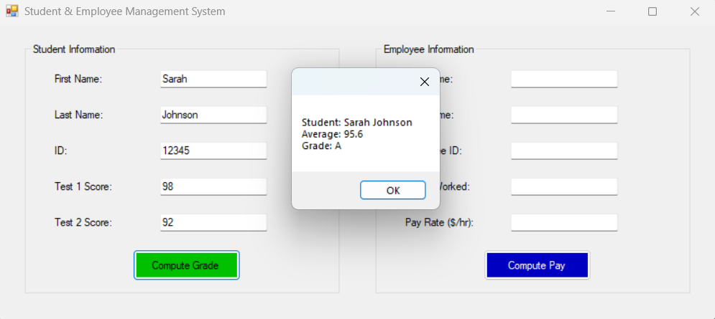

Example 2: Student Needing Help
Now let's look at a student who's struggling:
- First Name: Michael
- Last Name: Rodriguez
- Test 1: 71
- Test 2: 68
The calculation:
Weighted Average = (71 × 0.6) + (68 × 0.4)
= 42.6 + 27.2 = 69.8%
Grade = Fail (since 69.8 < 73)
The program displays:
Student: Michael Rodriguez
Average: 69.8
Grade: Fail
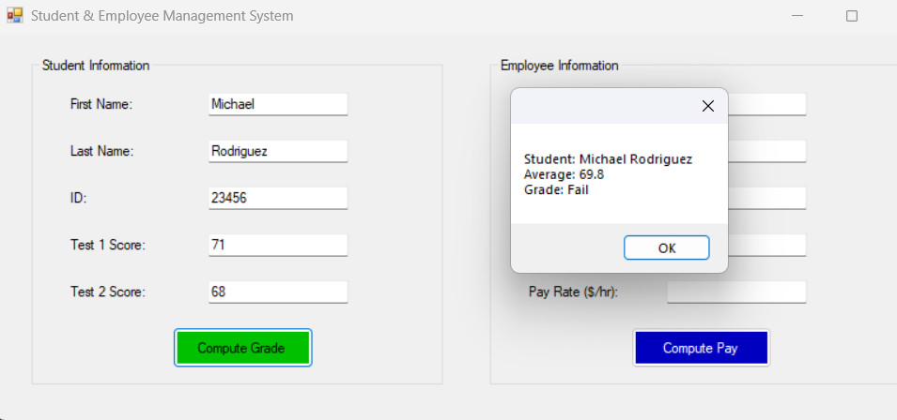

Example 3: Borderline Case - Here's an interesting case where the weighting makes a difference:
- Test 1: 85 (weighted heavily)
- Test 2: 90 (weighted less)
Weighted Average = (85 × 0.6) + (90 × 0.4)
= 51.0 + 36.0 = 87.0%
Grade = B+ (exactly at the 87% cutoff)
If I had just averaged them: (85 + 90) ÷ 2 = 87.5%, but the weighting brings it down to exactly 87%.

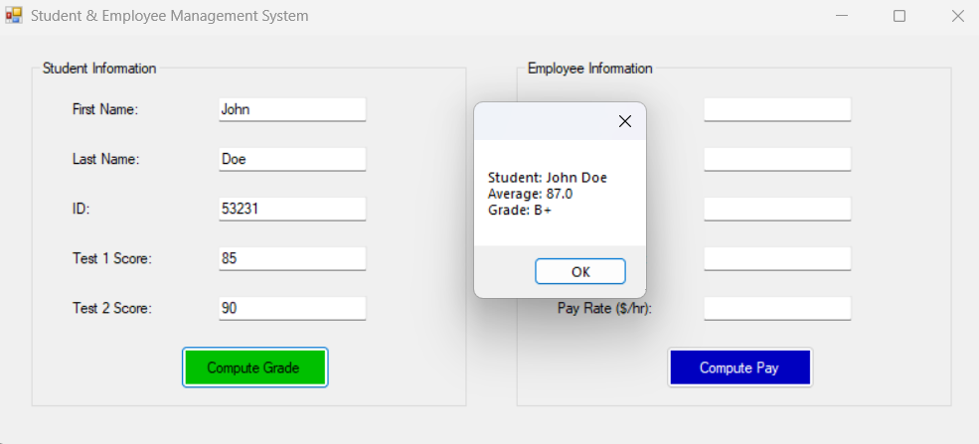

How the Employee Payroll System Works
The Employee Class
The Employee class handles all the complexity of calculating paychecks. I used the same property structure as the Student class:

private double hoursWorked;
public double HoursWorked
{
get { return hoursWorked; }
set { hoursWorked = value; }
}

The class includes constants for standard calculations:

private const double STANDARD_WORK_WEEK = 40.0;
private const double OVERTIME_MULTIPLIER = 1.5;

Payroll Calculation Methods
I created several methods to handle different aspects of payroll:
ComputePay() - Main calculation method:

public double ComputePay()
{
if (hoursWorked <= STANDARD_WORK_WEEK)
{
// No overtime - regular pay only
totalPay = hoursWorked * payRate;
}
else
{
// Overtime calculation
double overtimeHours = hoursWorked - STANDARD_WORK_WEEK;
double overtimeRate = payRate * OVERTIME_MULTIPLIER;
totalPay = (STANDARD_WORK_WEEK * payRate) + (overtimeHours * overtimeRate);
}
return totalPay;
}

ComputeOvertimePay() - Calculates just the overtime portion: This method returns the overtime pay amount separately, which is useful for detailed pay stubs.
HasOvertime() - Simple boolean check:

public bool HasOvertime()
{
return hoursWorked > STANDARD_WORK_WEEK;
}

Real Payroll Examples
Example 1: No Overtime - Employee working regular hours:
- Jessica Park, ID: 1001
- Hours: 35.0
- Pay Rate: $18.50

Calculation:
Total Pay = 35.0 × $18.50 = $647.50
Overtime Pay = $0.00 (no overtime hours)

The program displays:
Employee: Jessica Park
Hours Worked: 35
Pay Rate: $18.50/hr

Regular Pay: $647.50
Overtime Pay: $0.00
Total Pay: $647.50

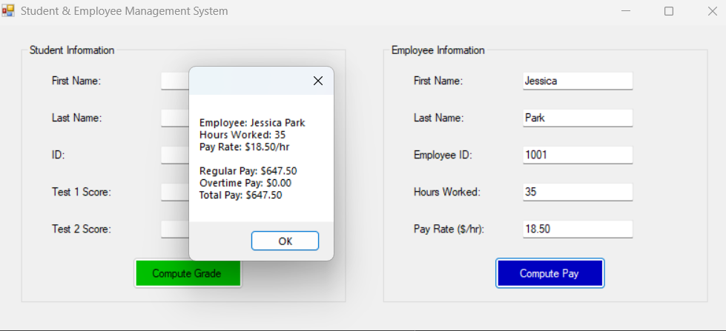

Example 2: With Overtime - Employee working extra hours:
- Robert Martinez, ID: 1002
- Hours: 48.0
- Pay Rate: $15.75

Calculation:
Regular Hours: 40.0 × $15.75 = $630.00
Overtime Hours: 8.0 hours
Overtime Rate: $15.75 × 1.5 = $23.625
Overtime Pay: 8.0 × $23.625 = $189.00
Total Pay: $630.00 + $189.00 = $819.00

The detailed output shows:
Employee: Robert Martinez
Hours Worked: 48
Pay Rate: $15.75/hr

Regular Pay: $630.00
Overtime Pay: $189.00
Total Pay: $819.00

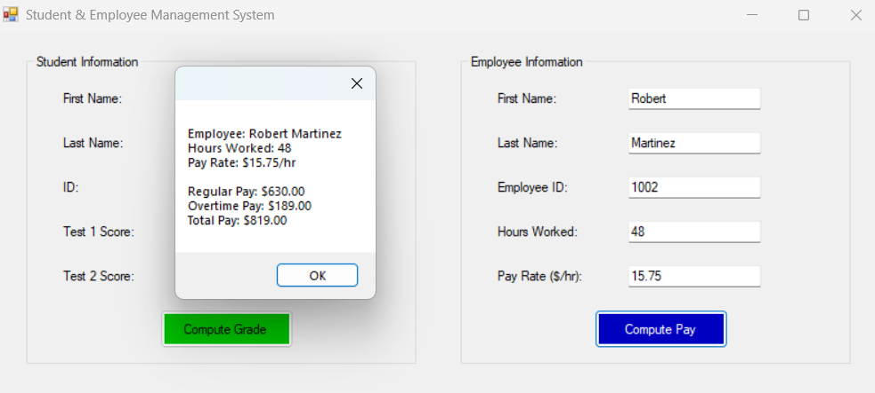

Example 3: High Overtime Scenario - Sometimes people work a lot of extra hours:
- Lisa Wilson, ID: 1003
- Hours: 55.0
- Pay Rate: $22.00
Calculation:
Regular Hours: 40.0 × $22.00 = $880.00
Overtime Hours: 15.0 hours
Overtime Rate: $22.00 × 1.5 = $33.00
Overtime Pay: 15.0 × $33.00 = $495.00
Total Pay: $880.00 + $495.00 = $1,375.00
Output:
Employee: Lisa Wilson
Hours Worked: 55
Pay Rate: $22.00/hr

Regular Pay: $880.00
Overtime Pay: $495.00
Total Pay: $1,375.00

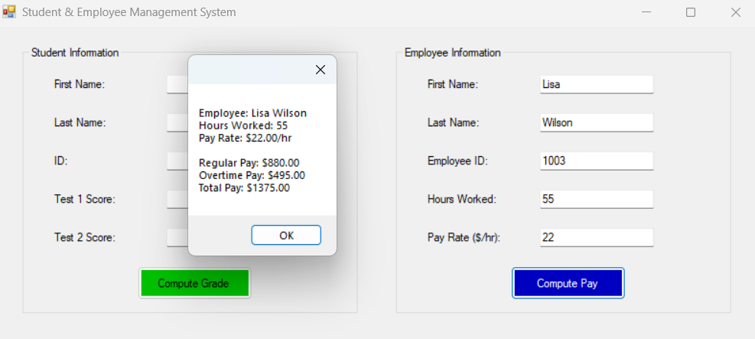

How the User Interface Works
Form Design
I used Visual Studio's Windows Forms designer to create two GroupBox sections:
- Student Information (left side) - with a green "Compute Grade" button
- Employee Information (right side) - with a blue "Compute Pay" button
Each section has labeled TextBox controls for all the required inputs, arranged in a clean, logical order.

Input Validation
I implemented validation methods to check that all fields are filled out before processing:

private bool ValidateStudentInputs()
{
return !string.IsNullOrWhiteSpace(txtFirstName.Text) &&
!string.IsNullOrWhiteSpace(txtLastName.Text) &&
!string.IsNullOrWhiteSpace(txtID.Text) &&
!string.IsNullOrWhiteSpace(txtTest1.Text) &&
!string.IsNullOrWhiteSpace(txtTest2.Text);
}
If validation fails, users see a clear error message: "Please fill in all student fields with valid data."

Event Handlers
When users click the buttons, the event handlers:
- Validate all inputs
- Parse the text values into appropriate data types
- Create Student or Employee objects
- Set all the properties
- Call the calculation methods
- Display results in formatted MessageBoxes

Error Handling
I wrapped the parsing and calculation code in try-catch blocks to handle invalid inputs gracefully:

try
{
int test1 = int.Parse(txtTest1.Text);
// ... rest of processing
}
catch (Exception ex)
{
ShowErrorMessage($"Input error: {ex.Message}");
}

